In the email with Subject “GRM module issues to be resolved”, it says
- Missing locations in the GRM module.
Missing in the state area.
- Ruweng Administrative
Missing Payams with all Bomas is missing.
- Melut.
- Paloch.
Comment: We need the bomas for these payams and also info about which state and county these payams will be under. Then we need to add these geolocation data in all three databases.

- Locations that appeared in the GBV sections and they are not SNSOP locations kindly remove the below locations
- Unity (Abienmhom). (State)
- Gogrial East. (County)
- Renk. (Payam)
- Terekeka. (Payam)
Comment: We do not keep geolocation data separately for each module. So, if we delete the geolocations, no beneficiary enrollment can be done from there either. If client confirms, we need to delete these geolocations from all three databases for uniformity.

- 17 GBV incidents currently in the MIS.
- Delete the 16 GBV incidents those are entered for testing.
- leave only 1 case with serial number (GBV000040).
Comment: Done.
- NGBV incidents, the MIS developers should
- Delete 17 grievances that were used for tests, from serial number (NGBV008227 to NGBV008247). They were entered from the 26th of April 2024 to 16th Sep.2024.
Comment: Done

- Recover lost grievance data the data were entered on the development environment and cannot be found on production Environment.
Comment: No data is lost. The grievances that were entered in the development environment are in the development database. The grievances that have been registered in the production environment are in the production database.
Moving data between two databases is a bit complex because these are two different databases and they have constraints and separate sequences. We advise the client to enter actual grievances in production environment only. The Development environment is just for practice and testing.
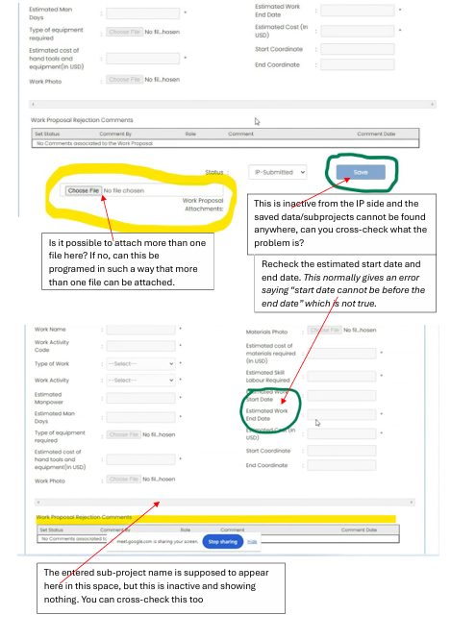
  - This is inactive from the IP side and the saved data/subprojects cannot be found anywhere, can you cross-check what the problem is?
Comment: When a sub-project is submitted by IP user, it goes to Quality Engineer for approval/rejection. If QE changes the value of this dropdown from “IP-Submitted” to “QE-Approved”/”QE-Rejected”, the save button will become active. Please refer to the user manual.
And all the saved data/subprojects can be found when user clicks the “lookup” button in this screen, actually that is how this UI comes filled with data. Please check the user manual.

  - Is it possible to attach more than one file here? If no, can this be programed in such a way that more than one file can be attached.
Comment: No, currently only one file can be attached here. If you want, we can add feature here so that multiple files can be attached. But we need to know the maximum number of files and maximum size that can be allowed. And it will take server space, so please keep it in consideration.

  - Recheck the estimated start date and end date. This normally gives an error saying “start date cannot be before the end date” which is not true.
Comment: When a user sets the start date of a sub-project, he must set the end date too. The error message (which actually says: “Estimated End Date cannot be earlier than Estimated Start Date”) reflects just that. If no start date is provided, the error message will not be shown.

  - The entered sub-project name is supposed to appear here in this space, but this is inactive and showing nothing. You can cross-check this too.
Comment: There is a text field in this UI for sub-project name. The text field’s label is work name. We can show it there. But the system currently does not hold the sub-project name in the database. We need to update that from code and stored procedure.
  - On TST approval dashboard, there is “Payam Development Committee (PDC) approval date which should be moved to IP so that this date (PDC approval date) can be entered by the engineering technicians when entering sub-projects. Or this should be removed from the TST approval interface.
Comment: I think what is meant here is the “Work Approval” page for TST, not dashboard. The PDC approval date can be moved so that it can entered by IP level users during sub-project creation. So, it will not be updatable by TST.
  - Once a sub-project is entered, the Quality engineer is supposed to receive an email alert and on approval by the Quality Engineer, the environmental specialist is supposed to receive an email alert too. After approval by Environmental specialist, TST is supposed to be notified on an email alert. All these are not happening, please check if this can be done.
Comment: We have found that these users were not marked as “email receivers” in our database. We have updated our dev and prod databases so that they receive all the applicable email notifications.

